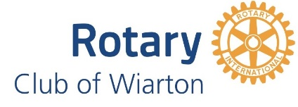 **Paul Harris Community Recipients 2012 to 2024**

**2012** Vicki Doubt, Joanne Lancaster

**2014** Paul Sutter, Jim and Val Mitchell

**2015** Gary and Bev Dillon, Jim Howe – Sauble and District Lion’s Club

**2016** Kathy Mason, Ruthann Pickett, Kelly McDougall, Charlie Torra

**2017** Dale Robinson, Joanne Thompson, Lloyd Hayward

**2018** Karin Vander Hayden, Ken Jones

**2019** Shelley Barfoot O’Neill & Brian O’Neill, Katrina (Kate) Rubinstein-Gilbert

**2022** Ralph & Guido Hafer (Connaisseur Food Concepts Ltd – Pancake Mix), Shirley Leeder, Nancy Ince

**2023** Tom and Stephanie Jellicoe, Mike Richardson Time Plane, Elaine Bell , Ed Laksmanis

**2024** Josie Myles, Becky Knight and Dan Lisk